

POST AND TELECOMMUNICATIONS INSTITUTE OF TECHNOLOGY
FACULTY OF INFORMATION TECHNOLOGY 1



FINAL REPORT
BUSINESS INTELLIGENCE
Topic: BI system for e-commerce data analytics

Class : E22HTTT
Lecturer : TS. Kim Ngọc Bách
Author : Đỗ Trung Quân - B22DCAT233
Nguyễn Minh Khiêm - B22DCDT170
Group : 14
Hanoi, 2026
TABLE OF CONTENTS
PREFACE 2
Chapter I: INTRODUCTION 3
1. Background and analysis objectives 3
2. Scope of the Business Intelligence (BI) system 3
Chapter II: DATASET DESCRIPTION 5
1. Data source and collection method 5
2. Details of key attributes 6
Chapter III: DATA WAREHOUSE DESIGN 8
1. Data Sources and Extraction Strategy 8
2. Data model diagram 9
Chapter IV: ETL PROCESS 10
1. Processing tools 10
2. Description of ETL steps 11
Chapter V: DASHBOARD DEVELOPMENT 16
1. Data visualization tool 16
2. Key charts and metrics 16
Chapter VI: INSIGHT ANALYSIS 20
1. Insights derived from data visualization 20
2. Trend evaluation and recommendations 22
Chapter VII: CONCLUSION 24
1. Results 24
2. Limitations and future development 24
REFERENCES 26

PREFACE
First and foremost, we would like to express our deepest and most sincere gratitude to the Posts and Telecommunications Institute of Technology and the Faculty of Information Technology 1. In an era increasingly driven by data, integrating the Business Intelligence course into our curriculum has been incredibly valuable. It has provided us with a crucial foundation for understanding how data analytics shapes modern software systems and business decisions.
We are profoundly grateful to our lecturer, Mr. Kim Ngoc Bach. Thank you for your unwavering dedication, patience, and the wealth of knowledge you have shared with us throughout this semester. Your lectures went beyond mere theoretical concepts; you brought the subject to life by showing us the real-world applications of data. Your passion for the field inspired us to look closer at the stories and insights hidden within raw numbers.
Through this course, we have not only grasped the core principles of Business Intelligence but also gained hands-on experience. Moving from abstract academic models to building visual dashboards and working with modern analytics tools like Tableau has significantly broadened our perspective. We have developed a more rigorous, analytical, and disciplined approach to problem-solving skills that will undoubtedly serve as a strong stepping stone for our future careers as software engineers and developers.
With your meticulous and thoughtful guidance, our team was able to navigate the complexities of our term project. Whenever we hit a roadblock in designing our system or structuring our data, your constructive feedback steered us in the right direction, allowing us to successfully bring our ideas to completion. We truly appreciate the time and effort you invested in mentoring us.
Once again, please accept our heartfelt appreciation. We wish you, Mr. Kim Ngoc Bach, abundant health, happiness, and continued success in both your personal life and your esteemed teaching career.

INTRODUCTION

Background and analysis objectives
In today's digital era, the e-commerce and omnichannel retail sectors are undergoing an unprecedented revolution. The rise of major e-commerce platforms, along with the booming trend of video and livestream shopping, is fundamentally transforming consumer behavior. Every day, these systems record millions of transactions, ranging from clicks and add-to-cart actions to payment flows and customer reviews.
As the volume and velocity of data generation reach massive levels, a critical challenge arises for retailers, platform administrators, and distributors: how to turn raw data into a competitive advantage. Operating a digital storefront or a retail platform based solely on intuition or personal experience inevitably leads to wasted marketing budgets, inefficient inventory management, and missed cross-selling opportunities. Core, profit-driving insights - such as the customer lifecycle, which promotional campaigns yield the highest Return on Investment (ROI), or which product groups pose a risk of dead stock - are often buried within fragmented databases.
Recognizing this context and the strong shift towards data-driven decision-making, our team identified the development of a comprehensive analytics pipeline for e-commerce as an urgent and highly practical problem. Consequently, we decided to choose the topic: BI system for e-commerce data analytics.
The objective of this project is to construct a complete processing pipeline, from collecting and cleaning historical transaction data to organizing, storing, and visualizing it through modern BI platforms (such as PowerBI). The system provides both high-level overviews and granular insights, enabling managers to closely monitor the business's "health", optimize the supply chain, personalize the customer experience, and ultimately increase profit margins.

Scope of the Business Intelligence (BI) system
The scope of this project focuses on the data processing and visualization pipeline for a historical dataset of Brazilian e-commerce transactions, specifically encompassing.
- Data scope: Mining and analyzing core e-commerce attributes, which include order values, customer details, product categories, and transaction dates.
- Data processing (ETL) scope: Extracting and cleaning raw data from multiple sources and organizing it into a multi-dimensional data model comprising a Fact table (Fact_Orders_Clean) and Dimension tables (Dim_Customer_Clean, Dim_Product_Clean, Dim_Time_Clean).
- Analytical and visualization scope: Developing interactive dashboards to deliver reports centered around three core themes:
  - Sales performance and revenue trends over time.
  - Product distribution and performance segmented by category.
  - Analysis of customer purchasing behaviors and order volumes.

DATASET DESCRIPTION

Data source and collection method
Data source: https://www.kaggle.com/datasets/olistbr/brazilian-ecommerce
The team adopted a warehouse-first approach. This means that data after extraction does not flow directly to the dashboard; it passes through a normalization and validation layer first. This introduces additional upfront design costs but ensures that the final report's figures are defensible. When the dashboard reports a total of 817 posts, that number is not a transient API result — it resides in a fact table, has passed quality gates, and has been reconciled against analytical views.
The project utilizes the “Brazilian E-Commerce Public Dataset by Olist” publicly available on the Kaggle platform. This dataset contains detailed information on approximately 100,000 anonymized orders made at multiple marketplaces in Brazil from 2016 to 2018. The raw dataset consists of 9 primary files, notably including:
- olist_orders_dataset.csv: Contains core transaction information, including order IDs, linked customer identifiers, order operational status, and crucial fulfillment timestamps (purchase, approval, shipping, and delivery).
- olist_order_items_dataset.csv: Details the specific items purchased within each order, including product IDs, seller IDs, individual item prices, and freight values.
- olist_customers_dataset.csv: Provides customer profiles, including anonymized unique identifiers (for tracking retention) and their geographic location parameters (zip code, city, state).
- olist_products_dataset.csv: Contains product metadata, including category names (in Portuguese), physical dimensions, and weight.
- product_category_name_translation.csv: A lookup table mapping the original Portuguese product category names to their English equivalents.
- olist_order_payments_dataset.csv: Records payment details for each transaction, specifying payment methods (e.g., credit card, boleto), number of installments, and payment values.
- olist_order_reviews_dataset.csv: Contains customer feedback data, including satisfaction scores (1 to 5), review comments, and submission timestamps.
- olist_sellers_dataset.csv: Provides information about the merchants fulfilling the orders, including seller identifiers and their geographic locations.
- olist_geolocation_dataset.csv: Contains precise geographical coordinates (latitude and longitude) mapped to Brazilian zip codes.
Note: In the current scope of this project, only the orders, order items, customers, products, and translation files are extracted to feed the core data warehouse. The remaining files (payments, reviews, geolocation, and sellers) are reserved for future analytical dimensions and are not processed in the current pipeline.
Collection method:
This static dataset has already been aggregated and anonymized by Olist and published on Kaggle in .csv format. Therefore, the data was collected by directly downloading these files from the Kaggle website to local storage, completely bypassing the need for manual web scraping or custom API calls.

Details of key attributes
Although the original dataset contains a vast amount of information across multiple files, to serve the BI system’s goals of analyzing sales trends, product performance, and customer behaviors, the project specifically extracts and utilizes only the core data attributes. Below are the most critical fields categorized by their business context:
- Identification and order information:
  - order_id: A unique identifier for each customer transaction.
  - order_item_id: A sequential identifier for individual items purchased within a single order, used to track basket sizes.
  - order_status: The operational state of the transaction (e.g., delivered, shipped, canceled), reflecting the fulfillment progress.
- Product details:
  - product_id: A unique identifier for each specific item available in the catalog.
  - product_category_name: The classification group of the product, essential for segmenting and analyzing performance across different retail sectors.
- Time dimensions for trend analysis:
  - order_purchase_timestamp: The exact date and time when the transaction was initiated.
  - day_of_week / month / quarter / year: Extracted chronological attributes serving as the foundation for time-series reporting and calculating revenue trends over different periods.
- Financial attributes:
  - price: The actual selling price of the individual product (in BRL).
  - freight_value: The logistics and shipping cost associated with delivering the item (in BRL).
- Derived attribute:
  - total_order_value: A derived metric representing the total monetary value of an order (item prices plus freight), used to evaluate Gross Merchandise Value (GMV) and Average Order Value (AOV).
- Customer and geographic attributes:
  - customer_id: An identifier tied to a specific order's delivery destination and account instance.
  - customer_unique_id: A unique identifier for the actual individual consumer, crucial for tracking returning buyers, calculating retention rates, and measuring purchasing frequency.
  - customer_city: The specific city of the buyer, used for detailed regional analysis.
  - customer_state: The state or province of the buyer, utilized to map broader sales density and consumer distribution across Brazil.

DATA WAREHOUSE DESIGN

Data Sources and Extraction Strategy
To construct an optimized data warehouse for querying and reporting e-commerce performance, the data model is designed using a Star Schema. The analysis of business entities and quantitative metrics has led to the identification of one central Fact table and three surrounding Dimension tables. Unlike models with many-to-many relationships, this structured schema directly connects dimensions to the fact table via one-to-many (1-to-*) relationships without the need for a bridge table:
Fact Table
Table fact_orders: This sits at the center of the data warehouse model, storing foreign keys that connect to the dimensions alongside quantitative, aggregable measurements (metrics/measures) and operational statuses.
- Keys and Identifiers: order_id, order_item_id (Line item identifiers); customer_id (links to the customer dimension), product_id (links to the product dimension), and date_key (links to the time dimension).
- Degenerate Attribute: order_status (stored directly in the fact table to quickly filter orders by their operational state, e.g., delivered, canceled).
- Measures: price and freight_value. These metrics directly support aggregation operations (such as SUM and AVERAGE) on the interactive dashboards to evaluate revenue and shipping costs.
Dimension Tables
Dimension tables provide descriptive context, enabling users to filter, group, and slice the quantitative data stored within the Fact table.
- Table dim_product: Stores the identifying attributes and categorical metadata for each product.
  - Attributes: id (Primary Key) and category_name. This dimension allows users to segment sales performance and revenue by specific product categories.
- Table dim_time: A dedicated time dimension designed to support historical trend analysis across various temporal granularities.
  - Attributes: date_key (Primary Key), day_of_week, month, quarter, and year. This table is essential for generating time-series line charts and tracking seasonal sales patterns.
- Table dim_customer: The customer dimension houses geographic data and unique identifiers to facilitate demographic and consumer behavior analysis.
  - Attributes: id (Primary Key linking to customer_id), unique_id (the actual identifier for the individual buyer), city, and state. This allows for spatial analysis and mapping of sales density across different regions.

Data model diagram
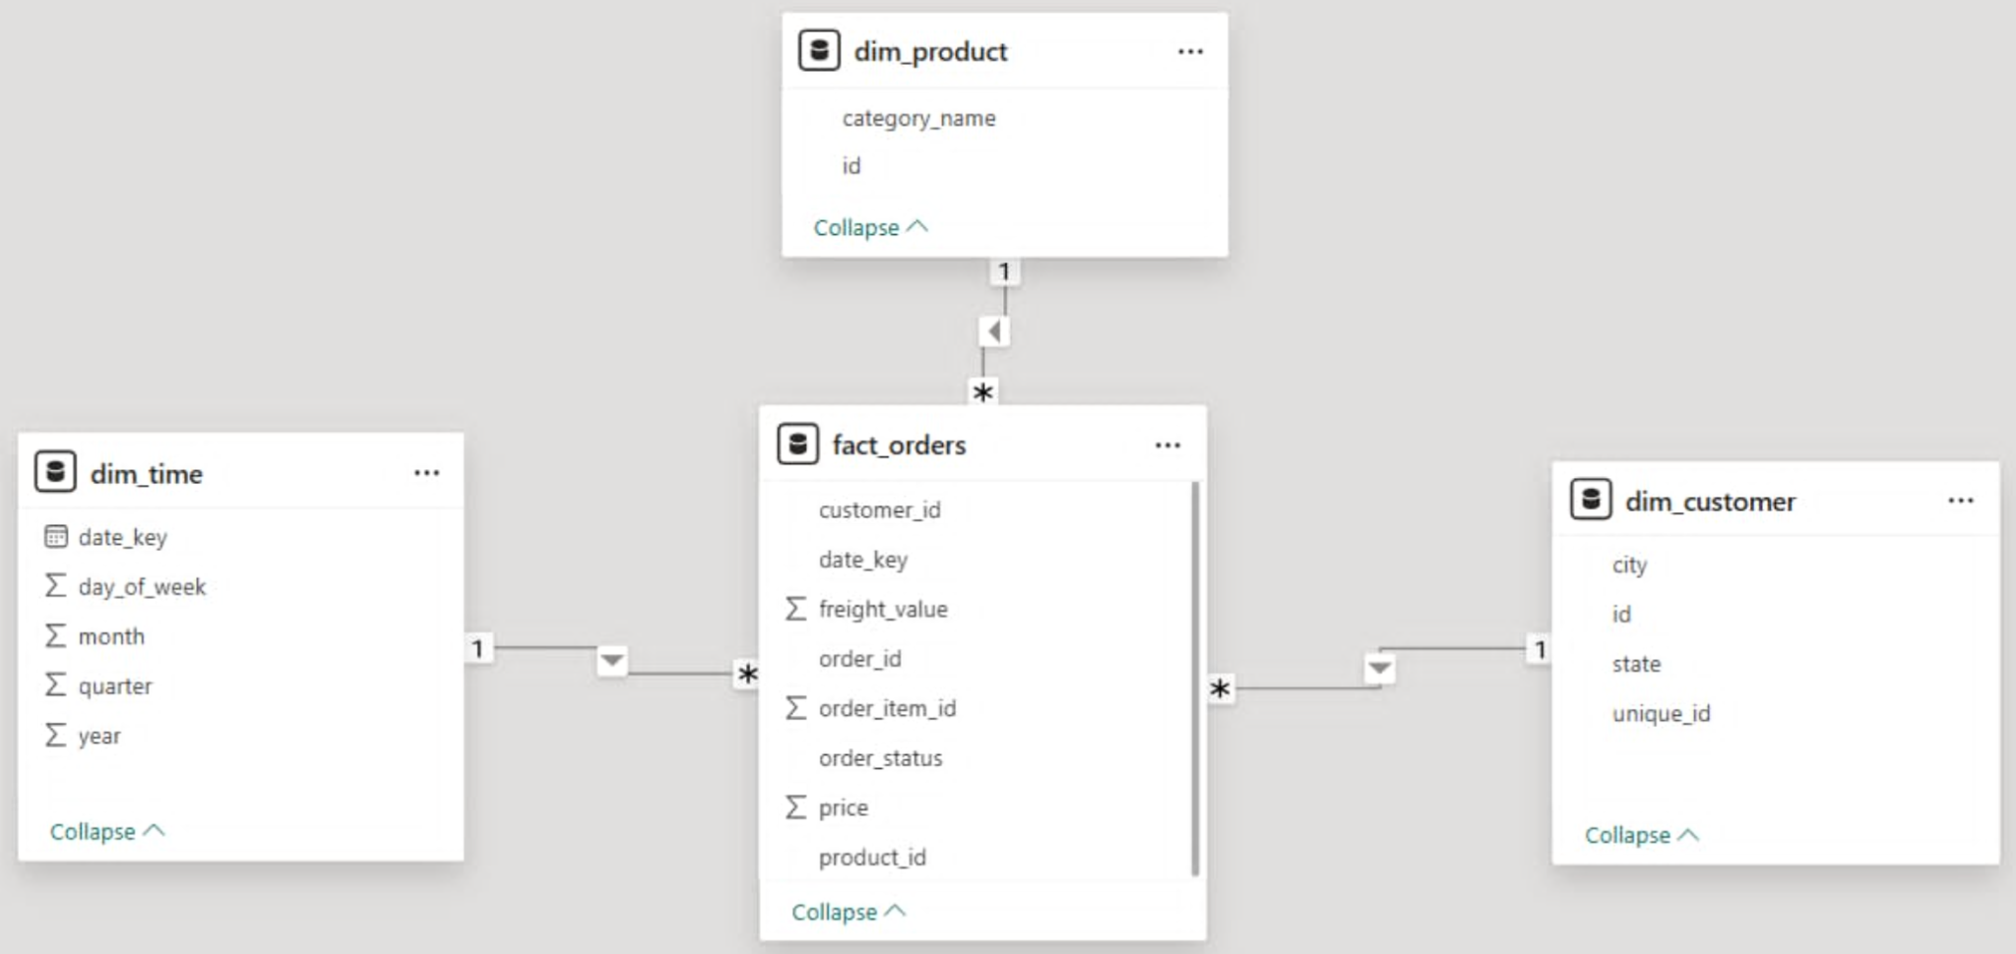

ETL PROCESS

Processing tools
Based on the specific complexities, multi-relational structure, and sheer volume of the Olist dataset (over 100,000 transactions), the ETL (Extract - Transform - Load) pipeline is engineered using a code-centric approach rather than relying solely on drag-and-drop GUI ETL software. This ensures maximum flexibility and computational efficiency. Specifically, the selected tools and technologies are:
Extract & transform tool: Python
- Description: The system utilizes Python within a Jupyter Notebook (VSCode) environment as the primary transformation engine. The process heavily relies on the pandas and numpy data manipulation libraries to extract raw data from the initial 9 CSV files and orchestrate the cleansing procedures.
- Reason for selection: The raw Olist dataset poses several unique data engineering challenges that visual tools struggle to handle efficiently. Python demonstrates absolute superiority in:
  - Complex Table Merging: Seamlessly joining highly fragmented transactional data into unified DataFrames.
  - Data Enrichment & Translation: Programmatically mapping and replacing Portuguese product category names with English equivalents.
  - Temporal Data Parsing: Converting messy string-based timestamps into standard datetime objects, extracting granular time components, and logically handling missing values in logistics milestones.
  - Deriving Metrics: Efficiently calculating aggregations and derived fields like total_order_value. Python allows for complete, optimal control over this transformation logic before exporting the normalized Star Schema tables.
Load Tool & Database: PostgreSQL.
- Description: PostgreSQL is employed as the robust Data Warehouse relational database management system. Standard SQL commands are executed during the Load phase to construct the physical Star Schema architecture.
- Reason for selection: Given the transactional nature and scale of e-commerce data, PostgreSQL provides enterprise-grade performance, advanced analytical capabilities, and a highly intuitive management interface (pgAdmin). The system leverages PostgreSQL's highly efficient COPY command and standard SQL queries to rapidly ingest the Python-processed clean CSV files into the database. Subsequently, basic Data Definition Language (DDL) and Data Manipulation Language (DML) commands are utilized to create tables, handle rigid data type casting (e.g., ensuring price and freight_value are strictly formatted as NUMERIC types), and insert data into the official Fact and Dimension tables. Finally, PostgreSQL enforces strict Primary Key and Foreign Key constraints, completely guaranteeing the referential integrity of the Data Warehouse before connecting it to BI visualization dashboards.

Description of ETL steps
The ETL process is designed as a rigorous and automated pipeline, divided into two primary phases: Pre-processing with Python (Extract & Transform) and Schema Definition & Loading into PostgreSQL (Load).
Phase 1: Extract & Transform (Using Python & Pandas)
- Extract: The system reads the raw data from 5 specific CSV files (olist_customers, olist_products, olist_orders, olist_order_items, and product_category_name_translation) from the local archive directory using the pandas library.
- Transform & Cleanse:
  - Data Enrichment & Translation: The raw product categories are recorded in Portuguese. The pipeline merges this data with the translation file using a LEFT JOIN to map and translate categories into English (product_category_name_english).
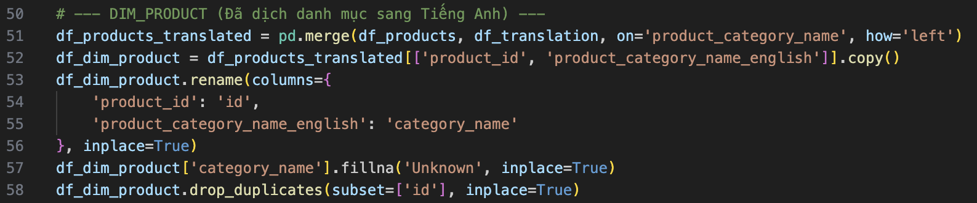
  - Handling missing values: Any missing or unmapped product category names are imputed with a default value ("Unknown").
  - Time Data Parsing: The order_purchase_timestamp column is converted into a standard Datetime format. From this, granular chronological components (date_key, year, month, quarter, day_of_week, hour) are extracted using .dt accessors to support time-series analysis and populate the Time dimension.
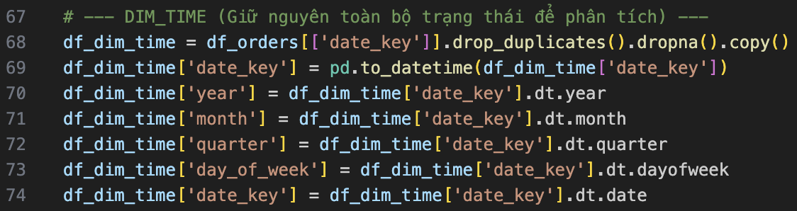
  - Deduplication: To ensure strict database integrity and prevent primary key violations, the script explicitly drops duplicates across all entities (e.g., subset id for customers/products, and the subset combination of order_id and order_item_id for the fact table).
  - Structuring & Exporting: The cleansed DataFrames are modeled into the final Star Schema structure: three Dimension tables (Dim_Customer, Dim_Product, Dim_Time) and one central Fact table (Fact_Orders containing price, freight_value, and order_status). These are subsequently exported as clean .csv files into a dedicated BI folder.
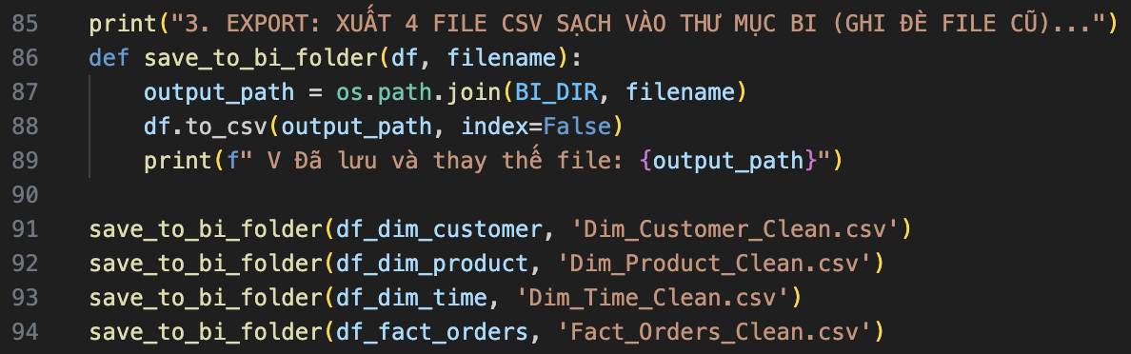

Phase 2: Load (Using PostgreSQL & SQLAlchemy)
- Schema Definition (DDL): Prior to data ingestion, standard SQL scripts are executed in PostgreSQL to construct the physical tables. Precise data types are declared (e.g., NUMERIC(10,2) for financial fields, DATE for time keys, VARCHAR for identifiers). Strict structural rules are enforced across the entire Star Schema: each Dimension table is assigned a distinct Primary Key (e.g., id for the Customer and Product tables, date_key for the Time table), while the Fact table utilizes a composite Primary Key (order_id, order_item_id) alongside explicit Foreign Key constraints linking back to the dimensions to maintain referential integrity.
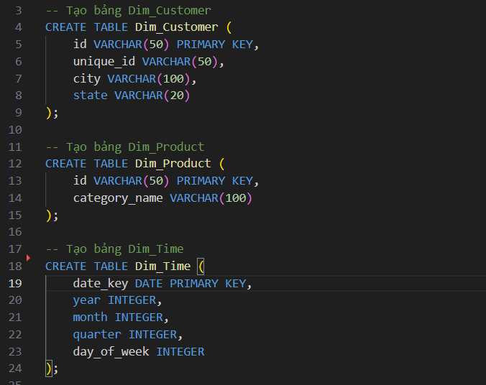

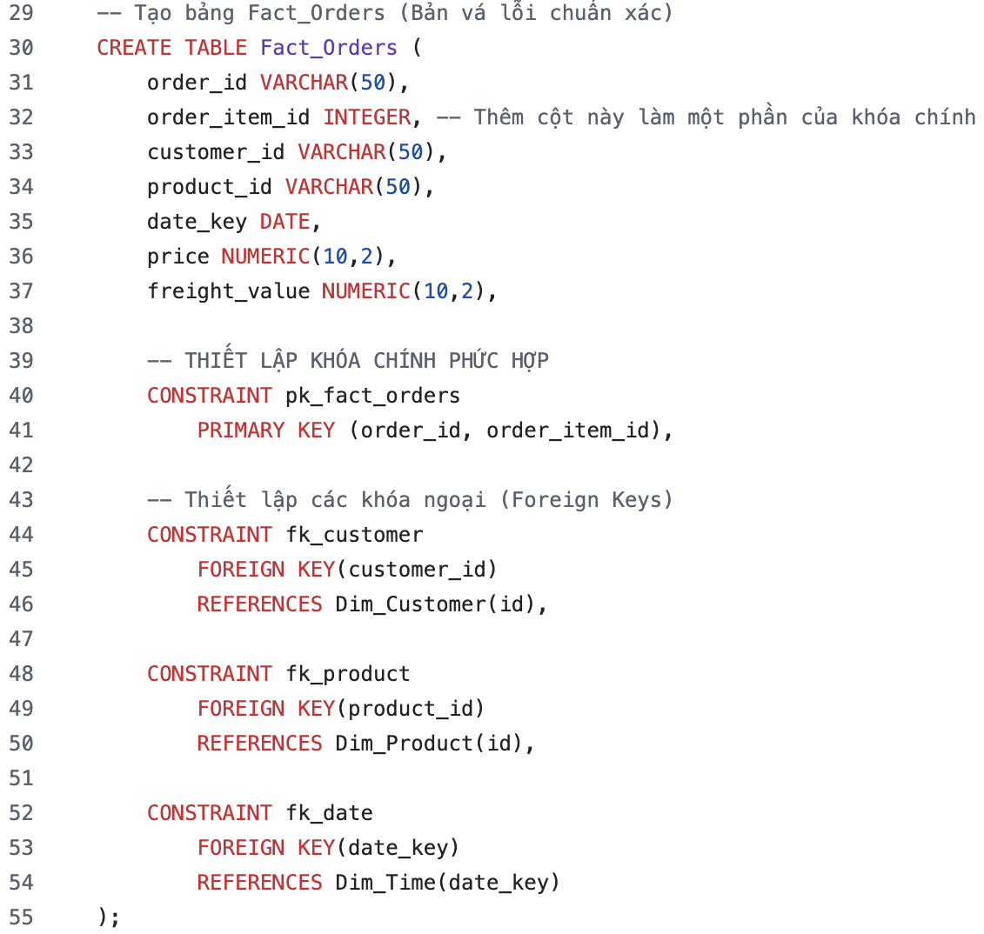
- Data Ingestion: The pipeline utilizes Python's SQLAlchemy library (create_engine) to establish a direct connection to the PostgreSQL database. The data is pushed using the to_sql(if_exists='append') method.
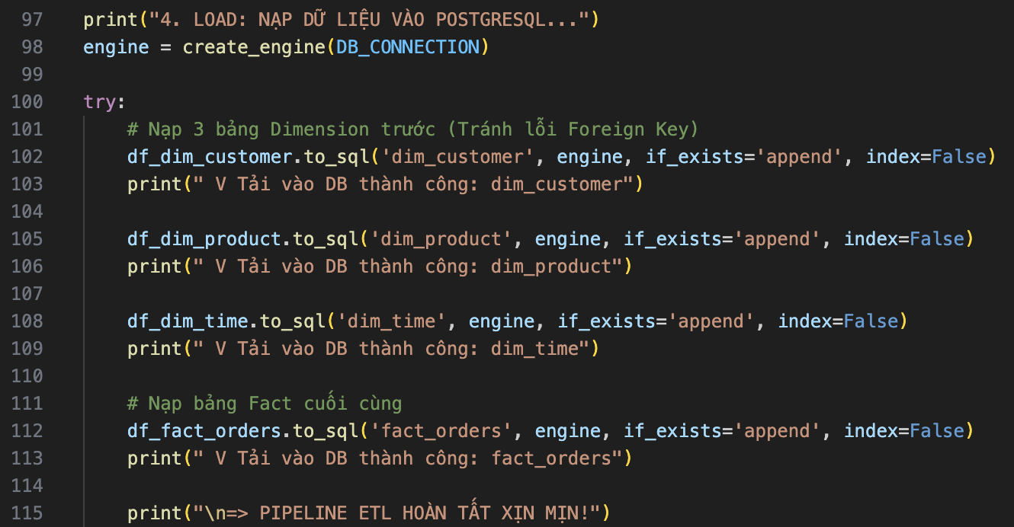
- Execution Order for Referential Integrity: The loading sequence is strictly managed. The dimension tables (dim_customer, dim_product, dim_time) are completely loaded first. The fact_orders table is loaded last. This intentional ordering ensures that all Foreign Key dependencies are fully respected without pipeline failures, completely guaranteeing the referential integrity of the Star Schema model.

DASHBOARD DEVELOPMENT

Data visualization tool
In this project, the team selected Microsoft Power BI as the primary tool for data visualization and dashboard development.
- Description: Power BI is a robust business analytics platform by Microsoft. It enables users to connect to diverse data sources, build data models, and design interactive dashboards using an intuitive drag-and-drop interface combined with the DAX (Data Analysis Expressions) formula language.
- Reason for selection: Power BI offers seamless native integration with SQL Server. Its Model View is exceptionally well-suited for managing the project's Star Schema (efficiently handling the 1-to-many relationships between the central Fact_Orders_Clean table and the surrounding dimensions). Additionally, DAX allows for the dynamic calculation of complex e-commerce metrics (like Average Order Value or Retention Rate) based on user filters, and its rich visual library perfectly fulfills all the core analytical requirements of the project.

Key charts and metrics
The dashboard is organized into three distinct report pages. They share a common dark-themed navigation pane on the left, which includes the page navigator and two global slicers under the "Filter" section—Year and Month—ensuring that every view can be filtered consistently across the entire dataset.
Core DAX measures: Total Orders, Total Revenue, Average Order Value (AOV), Delivery Rate, Total Customers, Orders / Customer, Revenue / Customer, Ordered Items, Items / Order, and Revenue / Product.
Orders & Revenue Dashboard.
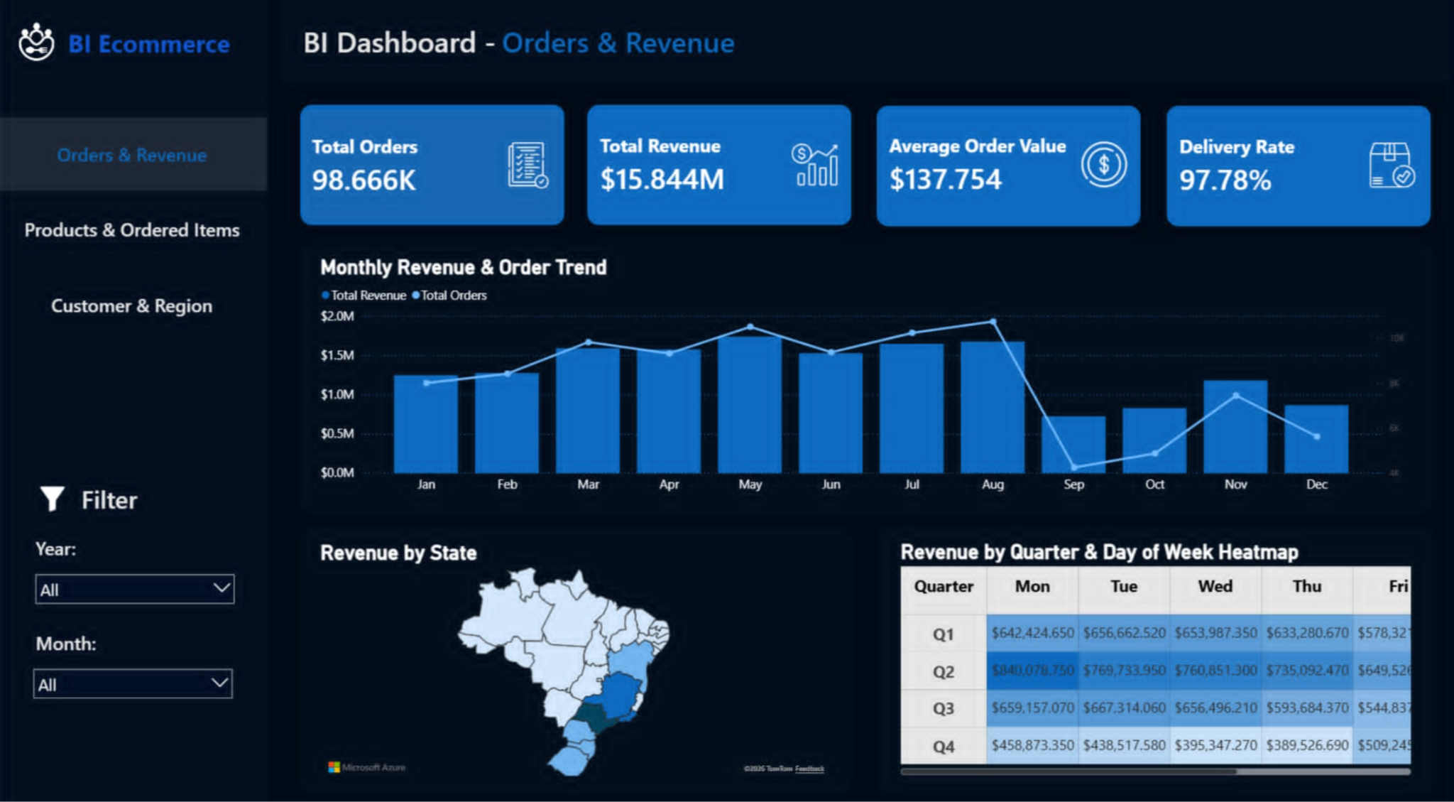
- KPI Cards: Total Orders, Total Revenue, Average Order Value, and Delivery Rate.
- Charts:
  - Monthly Revenue & Order Trend: A line-and-column combo chart showing the correlation between the volume of orders and total revenue across different months.
  - Revenue by State: A filled map visualizing the geographic concentration of revenue across Brazilian states (highlighting the dominance of the Southeast region).
  - Revenue by Quarter & Day of Week Heatmap: A matrix with conditional formatting that reveals which specific days of the week generate the most revenue across different quarters.
- Analytical Purpose: Answers high-level questions regarding the platform's overall financial health, seasonal revenue trends, and geographic performance.
Products & Ordered Items Dashboard.
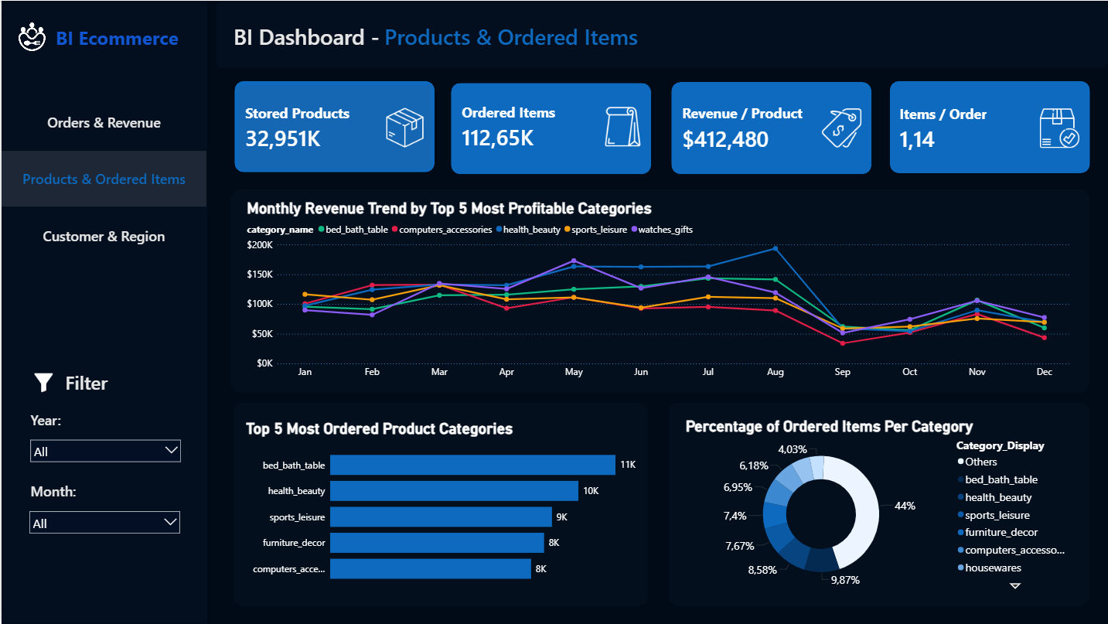
- KPI Cards: Stored Products, Ordered Items, average Revenue / Product, and average Items / Order.
- Charts:
  - Monthly Revenue Trend by Top 5 Most Profitable Categories: A multi-line chart tracking the monthly revenue performance of the top 5 product categories.
  - Top 5 Most Ordered Product Categories: A horizontal bar chart ranking the highest-performing categories.
  - Percentage of Ordered Items Per Category: A donut chart illustrating the market share distribution of the top categories versus the rest of the catalog ("Others").
- Analytical Purpose: Analyzes product catalog efficiency, identifies best-selling niches, and tracks category-specific trends over time.
Customer & Region Dashboard.
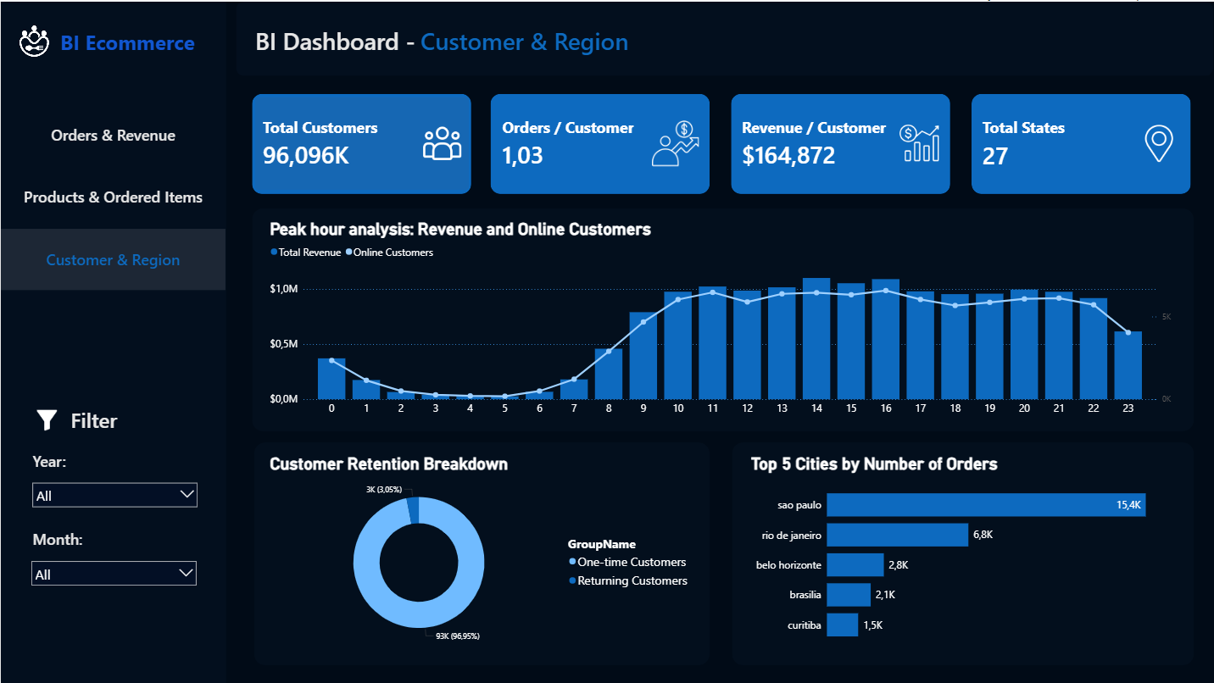
- KPI Cards: Total Customers, average Orders / Customer, average Revenue / Customer , and Total States.
- Charts:
  - Peak hour analysis (Revenue and Online Customers): A line and stacked column chart displaying purchasing behavior across a 24-hour cycle to pinpoint the most active shopping hours (0-23).
  - Customer Retention Breakdown: A donut chart evaluating customer loyalty by segmenting buyers into "One-time Customers" vs. "Returning Customers".
  - Top 5 Cities by Number of Orders: A horizontal bar chart identifying the specific urban centers driving the highest volume of transactions (e.g., São Paulo, Rio de Janeiro).
- Analytical Purpose: Provides deep insights into consumer behavior, shopping timing preferences, localized urban demand, and the critical state of customer retention.

INSIGHT ANALYSIS

Insights derived from data visualization
Orders & Revenue Dashboard.

- Overall Performance: The platform processed a total of 98.666K orders, generating an impressive $15.844M in total revenue. The Average Order Value (AOV) stands at a healthy $137.754, supported by an excellent Delivery Rate of 97.78%.
- Monthly Trends: Both revenue and order volumes show an upward trajectory from the beginning of the year, hitting peaks in May and August (approaching $2.0M). There is a sharp, unexplained dip in September and October, followed by a noticeable spike in November (likely driven by Black Friday/Cyber Monday sales).
- Temporal Heatmap: According to the Quarter & Day of Week Heatmap, mid-week days (Monday, Tuesday, Wednesday) are consistently the most profitable. For instance, Mondays in Q2 generated the highest revenue block at roughly $840K, while weekend sales are noticeably lower.
- Geographic Revenue: The state map clearly illustrates that the vast majority of revenue is heavily concentrated in the Southeast region of Brazil.
Products & Ordered Items Dashboard.

- Product Metrics: Out of 32.951K stored products, a total of 112.65K items were ordered. Customers purchase an average of 1.14 items per order, and the average revenue generated per product is $412.480.
- Top Categories: The Top 5 Most Ordered Categories are completely dominated by domestic and lifestyle goods: bed_bath_table leads with 11K orders (9.87%), followed by health_beauty (10K / 8.58%), sports_leisure (9K / 7.67%), furniture_decor (8K / 7.4%), and computers_accessories (8K / 6.95%).
- Long-tail Distribution: Despite the dominance of the top 5, the "Others" category accounts for 44% of ordered items, indicating a very diverse and long-tail product catalog.
Customer & Region Dashboard.

- Customer Acquisition vs. Retention: The platform served 96.096K total customers, but there is a severe retention crisis. The Customer Retention Breakdown shows that 96.95% (93K) are one-time buyers, while only 3.05% (3K) are returning customers. This results in a critically low 1.03 orders per customer ratio.
- Hourly Activity: The Peak Hour Analysis reveals a highly predictable daily shopping pattern. Online customer activity and revenue climb sharply from 8:00 AM, plateau at a high level during office hours (10:00 AM - 4:00 PM), and experience a secondary peak in the late evening (8:00 PM - 10:00 PM).
- Top Cities: City-level data confirms the regional concentration. São Paulo is the absolute central hub with 15.4K orders, more than double the second-place city, Rio de Janeiro (6.8K), followed by Belo Horizonte (2.8K).

Trend evaluation and recommendations
Trend evaluation:
- The business has successfully scaled to process massive volumes ($15.844M revenue), but its growth model relies almost entirely on new customer acquisition due to an abysmal 3.05% return rate.
- E-commerce activity is heavily localized in the Southeast states and specific mega-cities (São Paulo, Rio de Janeiro).
- Consumers exhibit distinct behavioral patterns: they prefer shopping on weekdays (Mon-Wed) during office hours or late evenings, and heavily favor domestic/lifestyle product categories.
Recommendations:
- Focus on Customer Retention: Immediately implement loyalty programs, targeted email marketing, and retargeting ads to convert the 96.95% of one-time buyers into repeat customers. Increasing the orders/customer ratio is the most cost-effective way to boost revenue.
- Optimize Marketing Timing: Concentrate digital advertising budgets on Mondays, Tuesdays, and Wednesdays, specifically targeting the 10:00 AM - 4:00 PM and 8:00 PM - 10:00 PM peak hourly windows to maximize conversion rates.
- Strategic Inventory Placement: Since São Paulo and Rio de Janeiro generate the vast majority of orders, and top categories like bed_bath_table and furniture_decor are often bulky, inventory for these specific goods should be stockpiled in Southeast fulfillment centers to minimize freight costs.

CONCLUSION

Results
The team successfully built an end-to-end BI pipeline covering three core stages:
- ETL (Python/pandas): Extracted, cleansed, and consolidated raw data from multiple highly-relational CSV files. Successfully translated Portuguese product categories into English, handled missing timestamps in logistics data, and calculated derived metrics such as total_order_value. Output: 4 cleansed CSV files ready for modeling.
- Data Warehouse (PostgreSQL): Implemented a pure and optimized Star Schema using PostgreSQL's efficient COPY command alongside standard SQL queries for rapid and safe data ingestion. The architecture successfully centralized transactions into one core fact table (Fact_Orders_Clean) surrounded by three dimension tables (Dim_Customer_Clean, Dim_Product_Clean, Dim_Time_Clean), smoothly handling over 98.6K orders and 112.6K ordered items while enforcing strict referential integrity through Primary and Foreign Keys.
- Dashboard (BI Tool): Delivered an interactive, dark-themed report with 3 dedicated pages (Orders & Revenue, Products & Ordered Items, Customer & Region) utilizing custom DAX measures and shared filters (Year, Month) to answer core analytical business questions.
Overall, the system fulfills all functional requirements of the assignment and demonstrates a working, reproducible data-driven analytics workflow—from processing raw, fragmented e-commerce datasets to delivering interactive, actionable insights.

Limitations and future development
Limitations:
- Data timeframe: The dataset is a historical snapshot (covering 2016 - 2018) and does not reflect current post-pandemic e-commerce behaviors or market inflation.
- Lack of cost data: The original dataset lacks explicit Cost of Goods Sold (COGS) or marketing expenditure data. Therefore, the financial analysis is restricted to Gross Revenue and Freight Value, making it impossible to calculate exact net profit margins.
- Manual pipeline: The ETL process, data loading into SQL Server, and dashboard data refreshes are currently executed manually without an automated orchestration system.
Future development:
- Expand the Data Model: Integrate the remaining unused raw files (olist_order_reviews_dataset,olist_order_payments_dataset, olist_sellers_dataset) to build new dimensions. This will allow for in-depth analysis of customer sentiment (review scores), payment installment habits, and seller performance.
- Pipeline Automation: Implement modern ETL orchestration tools such as Apache Airflow or Prefect to schedule incremental data loading, manage task dependencies, and automate dashboard refreshes without manual intervention.
- Predictive Analytics: Layer machine learning models onto the Data Warehouse to predict customer churn (since the current retention rate is critically low at 3%) or to forecast delivery delays based on freight routes and product dimensions.

REFERENCES
[1] Olist. (2018). Brazilian E-Commerce Public Dataset by Olist. Kaggle. Retrieved from
https://www.kaggle.com/datasets/olistbr/brazilian-ecommerce
[2] Kimball, R., & Ross, M. (2013). The Data Warehouse Toolkit: The Definitive Guide to Dimensional Modeling (3rd ed.). Wiley.
[3] McKinney, W. (2022). Python for Data Analysis: Data Wrangling with pandas, NumPy, and Jupyter (3rd ed.). O'Reilly Media.
[4] Microsoft. (2023). Data Analysis Expressions (DAX) Reference. Retrieved from https://learn.microsoft.com/en-us/dax/
[5] Few, S. (2013). Information Dashboard Design: Displaying Data for At-a-Glance Monitoring (2nd ed.). Analytics Press.

